HANDS ON WEEK-2
SPRING CORE_MAVEN
Exercise 1: Configuring a Basic Spring Application
1. pom.xml
<project xmlns="http://maven.apache.org/POM/4.0.0"
xmlns:xsi="http://www.w3.org/2001/XMLSchema-instance"
xsi:schemaLocation="http://maven.apache.org/POM/4.0.0
https://maven.apache.org/xsd/maven-4.0.0.xsd">
<modelVersion>4.0.0</modelVersion>
<groupId>com.library</groupId>
<artifactId>LibraryManagement</artifactId>
<version>1.0</version>
<dependencies>
<!-- Spring Core -->
<dependency>
<groupId>org.springframework</groupId>
<artifactId>spring-context</artifactId>
<version>5.3.30</version>
</dependency>
</dependencies>
</project>
2. BookRepository.java
package com.library.repository;

public class BookRepository {

public void displayBooks() {
System.out.println("Displaying books from BookRepository...");
}
}
3. BookService.java
package com.library.service;

import com.library.repository.BookRepository;

public class BookService {

private BookRepository bookRepository;

// Setter Injection
public void setBookRepository(BookRepository bookRepository) {
this.bookRepository = bookRepository;
}

public void showBooks() {
System.out.println("BookService is calling BookRepository...");
bookRepository.displayBooks();
}
}
4. applicationContext.xml
<?xml version="1.0" encoding="UTF-8"?>

<beans xmlns="http://www.springframework.org/schema/beans"
xmlns:xsi="http://www.w3.org/2001/XMLSchema-instance"
xsi:schemaLocation="
http://www.springframework.org/schema/beans
https://www.springframework.org/schema/beans/spring-beans.xsd">

<!-- Repository Bean -->
<bean id="bookRepository"
class="com.library.repository.BookRepository"/>

<!-- Service Bean -->
<bean id="bookService"
class="com.library.service.BookService">

<property name="bookRepository"
ref="bookRepository"/>

</bean>

</beans>
5. MainApp.java
package com.library;

import org.springframework.context.ApplicationContext;
import org.springframework.context.support.ClassPathXmlApplicationContext;

import com.library.service.BookService;

public class MainApp {

public static void main(String[] args) {

ApplicationContext context =
new ClassPathXmlApplicationContext("applicationContext.xml");

BookService service =
context.getBean("bookService", BookService.class);

service.showBooks();
}
}
OUTPUT:
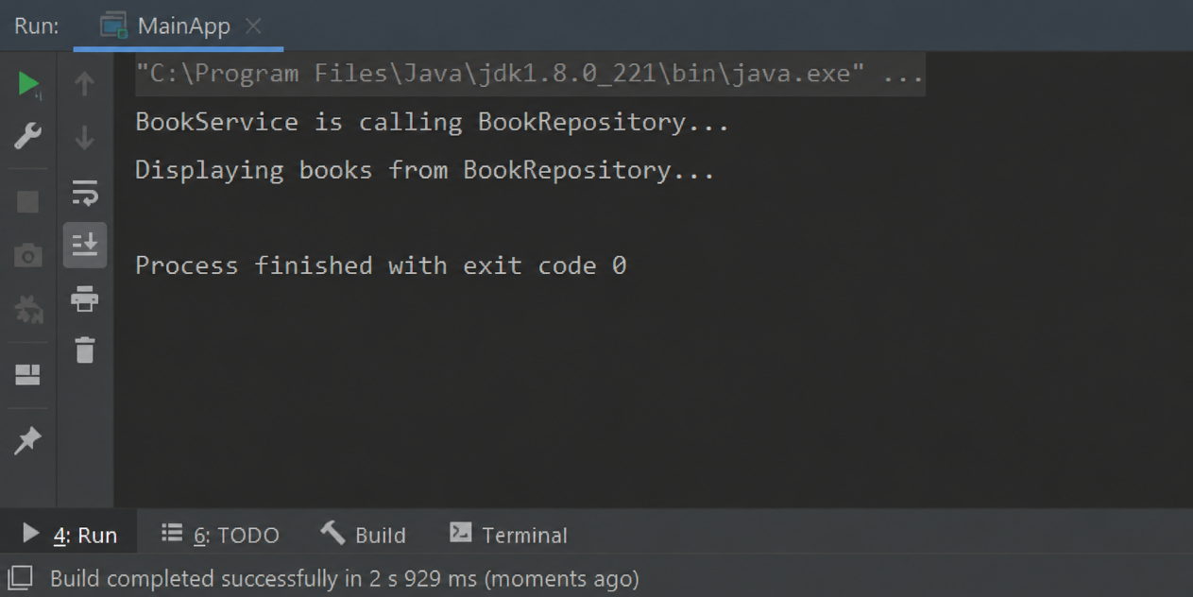
Exercise 2: Implementing Dependency Injection
1. pom.xml
<project xmlns="http://maven.apache.org/POM/4.0.0"
xmlns:xsi="http://www.w3.org/2001/XMLSchema-instance"
xsi:schemaLocation="http://maven.apache.org/POM/4.0.0
https://maven.apache.org/xsd/maven-4.0.0.xsd">
<modelVersion>4.0.0</modelVersion>
<groupId>com.library</groupId>
<artifactId>LibraryManagement</artifactId>
<version>1.0</version>
<dependencies>
<dependency>
<groupId>org.springframework</groupId>
<artifactId>spring-context</artifactId>
<version>5.3.30</version>
</dependency>
</dependencies>
</project>
2. BookRepository.java
package com.library.repository;

public class BookRepository {

public void getBookDetails() {
System.out.println("Book details fetched from BookRepository.");
}

}
3. BookService.java
package com.library.service;

import com.library.repository.BookRepository;

public class BookService {

private BookRepository bookRepository;

// Setter Injection
public void setBookRepository(BookRepository bookRepository) {
this.bookRepository = bookRepository;
}

public void displayBook() {
System.out.println("BookService is using BookRepository...");
bookRepository.getBookDetails();
}
}
4. applicationContext.xml
<?xml version="1.0" encoding="UTF-8"?>

<beans xmlns="http://www.springframework.org/schema/beans"
xmlns:xsi="http://www.w3.org/2001/XMLSchema-instance"
xsi:schemaLocation="
http://www.springframework.org/schema/beans
https://www.springframework.org/schema/beans/spring-beans.xsd">

<!-- Repository Bean -->
<bean id="bookRepository"
class="com.library.repository.BookRepository"/>

<!-- Service Bean with Dependency Injection -->
<bean id="bookService"
class="com.library.service.BookService">

<property name="bookRepository"
ref="bookRepository"/>

</bean>

</beans>
5. LibraryManagementApplication.java
package com.library;

import org.springframework.context.ApplicationContext;
import org.springframework.context.support.ClassPathXmlApplicationContext;

import com.library.service.BookService;

public class LibraryManagementApplication {

public static void main(String[] args) {

ApplicationContext context =
new ClassPathXmlApplicationContext("applicationContext.xml");

BookService service =
context.getBean("bookService", BookService.class);

service.displayBook();
}
}
OUTPUT:
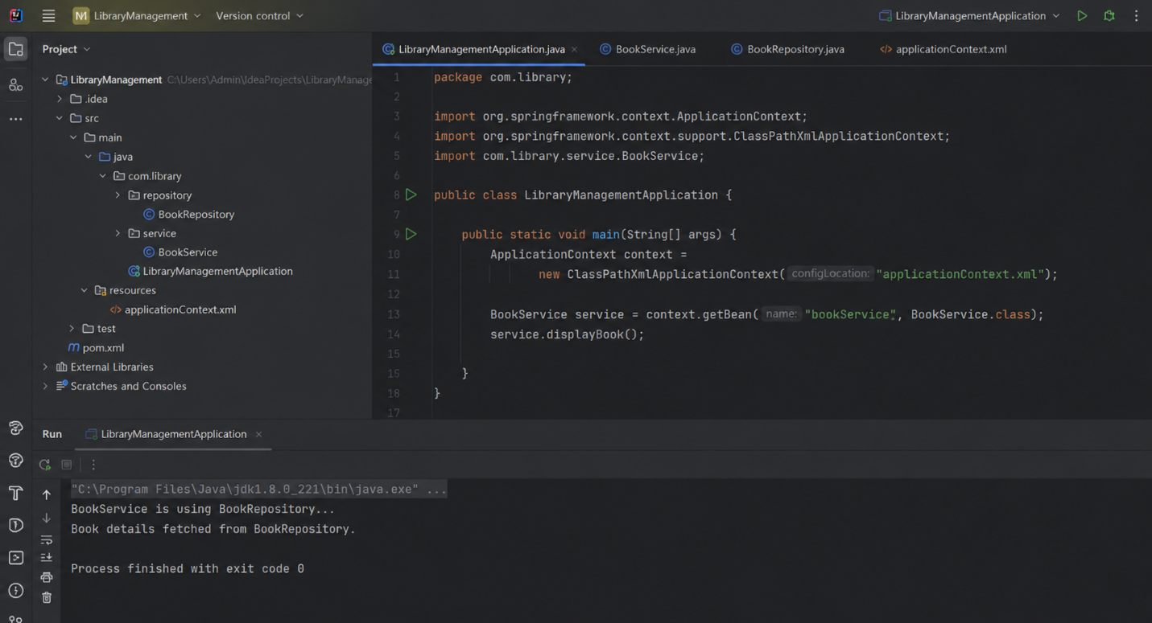

Exercise 4: Creating and Configuring a Maven Project
- pom.xml
<project xmlns="http://maven.apache.org/POM/4.0.0"
xmlns:xsi="http://www.w3.org/2001/XMLSchema-instance"
xsi:schemaLocation="http://maven.apache.org/POM/4.0.0
https://maven.apache.org/xsd/maven-4.0.0.xsd">

<modelVersion>4.0.0</modelVersion>

<groupId>com.library</groupId>
<artifactId>LibraryManagement</artifactId>
<version>1.0</version>

<dependencies>

<!-- Spring Context -->
<dependency>
<groupId>org.springframework</groupId>
<artifactId>spring-context</artifactId>
<version>5.3.30</version>
</dependency>

<!-- Spring AOP -->
<dependency>
<groupId>org.springframework</groupId>
<artifactId>spring-aop</artifactId>
<version>5.3.30</version>
</dependency>

<!-- Spring Web MVC -->
<dependency>
<groupId>org.springframework</groupId>
<artifactId>spring-webmvc</artifactId>
<version>5.3.30</version>
</dependency>

</dependencies>

<build>
<plugins>

<!-- Maven Compiler Plugin -->
<plugin>
<groupId>org.apache.maven.plugins</groupId>
<artifactId>maven-compiler-plugin</artifactId>
<version>3.10.1</version>

<configuration>
<source>1.8</source>
<target>1.8</target>
</configuration>

</plugin>

</plugins>
</build>

</project>
- LibraryManagementApplication.java
package com.library;

public class LibraryManagementApplication {

public static void main(String[] args) {

System.out.println("Library Management Maven Project Configured Successfully.");
System.out.println("Spring Context Dependency Added.");
System.out.println("Spring AOP Dependency Added.");
System.out.println("Spring WebMVC Dependency Added.");

}

}

OUTPUT:
